Power BI -Overview

**Product Overview**

* Microsoft Power BI is a cloud-based business intelligence and analytics service that provides a full overview of your most critical data. Connecting to all of your data sources, Power BI simplifies data evaluation and sharing with scalable dashboards, interactive reports, embedded visuals and more.
* Power BI works through two products that are available to download: Power BI Desktop and Power BI Mobile.
* Desktop is an on-premise solution that connects to a cloud-based service to easily upload and share data and information across the company.

**Features**

All of Microsoft Power BI’s functions are built for its three main features:

1. **Datasets**: As defined by Microsoft, “a dataset is something you can import or connect to. This reduces the time-consuming tasks associated with data capture, access and evaluation, making it easy to identify trends and make business decisions.
2. **Dashboards**: Dashboards are interactive panels that correlate disparate data through smaller displays called tiles. Dashboards are linked to each dataset for comparison and evaluation, and they can be shared with colleagues to easily exchange information.
3. **Reports**: Power BI’s reports can be created from scratch to ensure only critical information is included. These custom reports can be imported to any dashboard for quick, simple sharing among colleagues.

**Additional features the solution offers are:**

* **Navigation pane**: With the navigation pane, you can smoothly shift through datasets, dashboards and reports.
* **Q&A question box**: The Q&A question box allows you to explore data by asking a question in natural language. The technology uses rephrasings, autofill, suggestions and more to help you find the correct answer the first time.
* **Help & feedback buttons**: These are resource buttons for settings, downloads, getting support and providing feedback to the Power BI team.
* **Office 365 app launcher**: This allows you to quickly open the Office 365 apps you want and need.

**Target Market**

Microsoft’s solutions have simplified the BI initiatives of businesses, schools, other software companies, law enforcement and more.

Below are examples of some notable clients:

* Adobe
* HP
* Fordham University
* Honeywell
* Kansas State University
* Kelly Roofing
* Pepsi
* Seattle Seahawks
* Toshiba

**Implementation/Integration**

Microsoft Power BI is a cloud-based service that’s simple to implement. The only requirement is to sign up and download the technology to start correlating and evaluating critical business data.

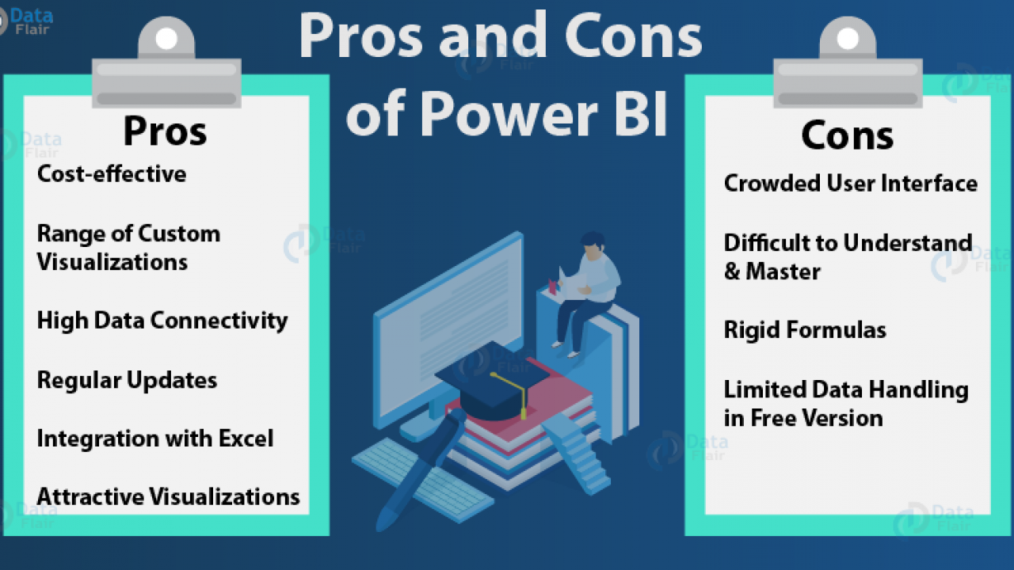

**Pricing**

Power BI comes in three levels – Desktop, Pro, and Premium. The Desktop level is free for individual users, while the Pro plan costs $9.99 per user per month. The Premium plan starts at $4,995 a month per dedicated cloud compute and storage resource.

